**Unit 2 Theory of Evolution**

**Section 1 – History of Evolutionary Thought**

**Section 2 – Evidence of Evolution**

**Section 3 – Evolution in Action**

**2-1 History of Evolutionary Thought-Objectives**

* Define the biological process of evolution.
* Summarize the history of scientific ideas about evolution.
* Describe Charles Darwin’s contributions to scientific thinking about evolution.
* Analyze the reasoning in Darwin’s theory of evolution by natural selection.
* Relate the concepts of adaptation and fitness to the theory of natural selection.

**The Idea of Evolution**

* __________________________________, an English naturalist; travel on the HMS Beagle in the 1830’s
* During these travels they visited the __________________________________.
* He was responsible to cataloging and recording the plants and animals they found on this journey.
* He noted that tortoises on the same island resemble each other closely, but those on neighboring islands were different.
* He became convinced that organisms change over time and he wanted to understand why

**The Idea of Evolution**

* __________________________________ is the development of new types of organisms from preexisting types of organisms over time
* __________________________________in characteristics within a population from one generation to the next.
* He formed his theory to explain how evolution could occur
* He took years to put together the data from many sources and to take account of the ideas of other scientists of his time.

**Ideas of Darwin’s Time**

* During the 18th century it was believed by most scientists that species were permanent __________________________________. They also believed that the Earth was only thousands of years old and not billions of years old.

**Ideas About Geology**

* In Europe scientists started to study __________________________________and found that they are formed as new layers of rock are deposited over time.
* Lower strata formed first
* Found fossils of different kinds of organisms
* __________________________________ (anatomist) spend years reconstructing the appearance of unique organisms from fossil bones.
* __________________________________ *– the idea that sudden geological catastrophes caused the extinction of large groups of organisms at certain points in the past*

**Strata/Fossil**

**Ideas About Geology**

* Charles Lyell thought that the geologic processes that have changed the shape of Earth’s surface in the past continue to work in the same ways - _________________________
* *Darwin refers to Lyell’s work in his writings*

**Lamarck’s Ideas on Evolution**

* Jean Baptiste Lamarck
* Thought that simple organisms could arise from nonliving matter
* Simple forms of life inevitably develop into more complex forms
* Individuals could acquire traits during their lifetime as a result of experience or behavior, then could pass on those traits to offspring – __________________________________

**Darwin’s Ideas**

* Both Charles Darwin and Alfred Russel Wallace formed similar ideas about evolution
* Darwin’s work was based off of his voyage aboard the HMS Beagle during the 1830’s
* Darwin’s published __________________________________in 1859 a year after he presented his work in London.
* His goals:
* To present the large amount of evidence that evolution occurs
* To explain the variety and distribution of organisms on Earth in terms of natural processes that are observable every day

**Darwin’s Voyage**

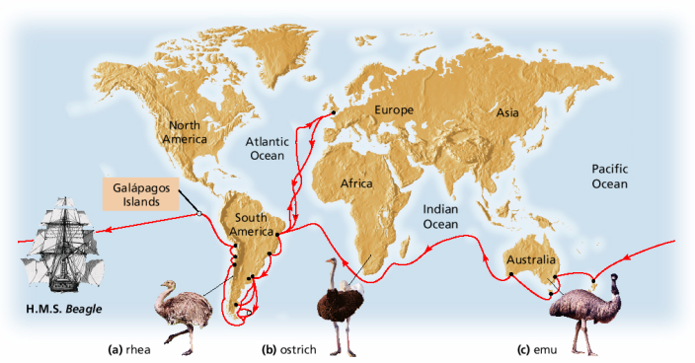

**Descent with Modification**

* __________________________________*–* the way organisms evolve.
* *Organisms must have descended by reproduction from preexisting species and that species must be able to change over time.*
* *He was the first person to argue that all species descended from only one or a few original kinds of life*
* *Galapagos Islands – 13 species of finch*

**Natural Selection**

* __________________________________*– a mechanism of evolution (decent with modification)*
* ***Survival of the fittest***

1. __________________________________

* More offspring are produced then will survive
* Thomas Malthus-book on human social problems and population growth

1. __________________________________tion

* Within a population individual have different traits

1. __________________________________

* Individuals must compete with each other
* “struggle for existence”

1. __________________________________

* Organisms with the best adaptations are most likely to survive and reproduce🡪passing on their traits to the next generation.

**Natural Selection**

* Nature selects those organisms with the best traits to survive, reproduce, and pass on those traits to the next generation
* These traits can be adaptations that allow the organism to survive certain environmental conditions
* Overtime an __________________________________ or species changes based on these environmental pressures.

**Natural Selection**

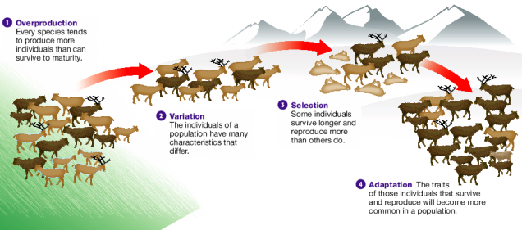

**2-1 Review**

1. Explain Darwin’s use of the phrase descent with modification to describe the process of evolution.

**2-2 Evidence of Evolution**

**2-2 Objectives**

* Relate several inferences about the history of life that are supported by evidence from fossils and rocks.
* Explain how the anatomy and development of organisms provide evidence of shared ancestry.
* Compare the use of biological molecules with other types of analysis of evolutionary relationships.
* Describe the ongoing development of evolutionary theory.

**The Fossil Record**

* __________________________________ show that different types of organisms appeared at different times and places on Earth.
* Some fossils are of organisms that have __________________________________.
* Fossils are among the most powerful evidence of evolution.

**The Age of Fossils**

* The principle of __________________________________ states that rock strata at a location that has not been disturbed, the lowest stratum is the oldest and newer layers are on the top.
* Therefore fossils found in lower strata are older.
* __________________________________-its age compared to that of other fossils-by referring to the geologic time scale and to records of known fossils.
* __________________________________– is determined by using radiometric dating.

**The Distribution of Fossils**

* We can infer that different organisms lived at different times.
* Rock strata hold different kinds of fossils in successive layers
* We can infer that today’s organisms are different from those of the past.
* Trilobites are unlike any organisms alive today
* We can infer that fossils found in adjacent layers are more alike each other than fossils found in deeper or higher layers
* Organisms that lived during closer time periods are more alike than organisms that lived in widely separated time periods.
* By comparing fossils and rocks from around the planet, we can infer when and where different organisms existed.

**Transitional Species**

* We can infer that species have differed in a gradual sequence of forms over time.
* __________________________________have features that are intermediate between those of hypothesized ancestors and later descended species.
* *This supports the* __________________________________*of species*
* The evolution of modern whales can be seen through a progression of transitional species.
* From found legged walking land mammals to modern day whales.
* *Pakicetus*
* Scientists think that whales evolved from land-dwelling mammals.
* *Ambulocetus*
* Lived in coastal waters about 49 million years ago. It could swim by kicking its legs and using its tails for balance. It could also waddle on land with its short legs*.*
* *Dorudon*
* Lived in the oceans about 40 million years ago. Resembles a giant dolphin and propelled itself with a massive tail. It had forelimbs that were flippers and tiny hind limbs that could not have been used for walking or swimming.
* Modern toothed whales
* Modern whales have forelimbs that are flippers. They also have tiny, nonfunctioning hip bones at the rear of their bodies.

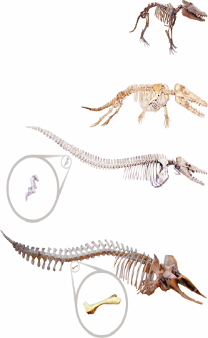

**Biogeography**

* __________________________________ is the study of the locations of organisms around the world.
* It was observed by Darwin and Wallace that:
* Animals that seemed closely related yet were adapted to different environments.
* Animals that seemed unrelated but that had similar adaptation to similar environments in regions that were far apart.

**Mammals of Australia**

* Animals that resemble wolves, cats, mice, moles, or anteaters, but are __________
* Isolation of the continent

**Anatomy**

* The bones in __________________________________ of humans, penguins, alligators, and bats are used in different ways, but each limb has a similar bone structure.
* Organisms share a very early ancestor and as time passed the organisms evolved into the different species with different uses for the limb

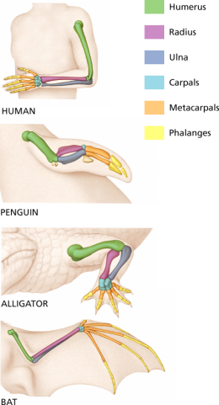

**Homologous structures**

* __________________________________are anatomical structures that occur in different species and that originate by heredity from a structure in the most recent common ancestor of the species
* Homologous organs often have a related structure even if their functions differ between species.

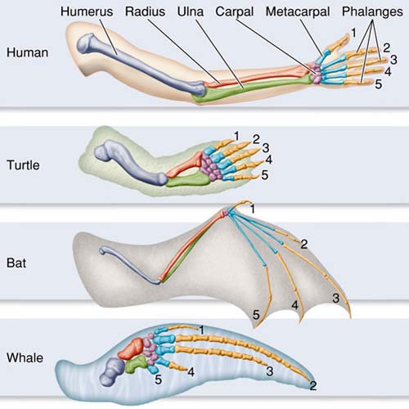

**Analogous Structures**

* __________________________________have closely related functions but do not derive from the same ancestral structure
* Even though birds, bats, and moths have wings, their winds have very different underlying structures.
* These wings evolved independently in each group of organism

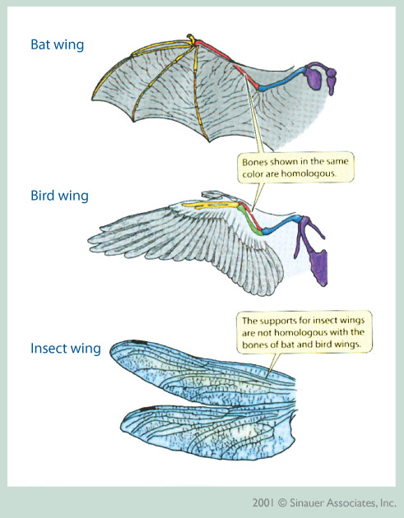

**Vestigial Structures**

* __________________________________serve no function but that resemble structures with functional roles in related organisms
* *Pelvic bone in whales*
* *Coccyx (tailbone) in humans*
* __________________________________

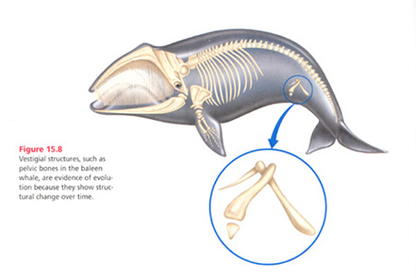

**Embryology**

* Stages of a __________________________________development are very alike
* In early development this fades further into development

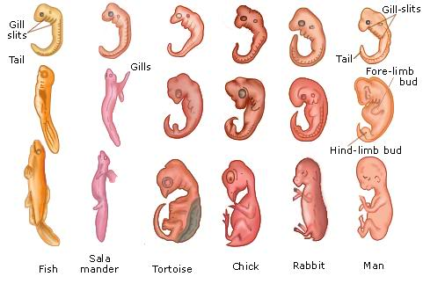

**Biological Molecules**

* Organisms that share many traits should have a more recent common ancestor that organisms that share fewer traits
* __________________________________, and other biological molecules can be compared to see relatedness.

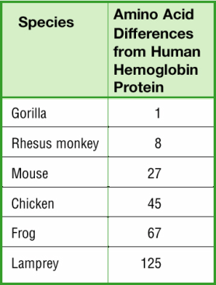

**Developing Theory**

* Modern synthesis of evolutionary theory
* Blends natural selection and genetic knowledge
* Continues to “evolve” with new scientific discoveries.

**2-2 Section Review**

1. Compare the concepts of homologous structures, analogous structures, and vestigial structures.

**2-3 Evolution in Action**

**Objectives**

* Describe how convergent evolution can result among different species.
* Explain how divergent evolution can lead to species diversity.
* Compare artificial selection and natural selection.
* Explain how organisms can undergo coevolution.

**Evolution in Action**

* Evolution is a __________________________________and can be observed, recorded and tested today.
* New species arise from environmental pressure and interactions with other species including humans.

**Case Study – Anole Lizard**

* Scientists have studied anole lizards of the Caribbean islands of Cuba, Hispaniola, Jamaica, and Puerto Rico.
* They have found at least six different bodies types each adapted to the particular environment they are found in.
* Anole lizards living on tree trunks
* __________________________________and long legs
* Anole lizards living on slender branches
* Thin bodies, __________________________________
* Anole lizards living in grass
* __________________________________ with very long tails
* Hypothesis to explain why body types are similar on all islands is:

1. An ancestral anole species specialized in living on twigs originally lived on one island and later migrated to other islands.
2. Each twig-dwelling species evolved independently on each island from distinct ancestor anole species.

* DNA analysis has revealed that __________________________________ is correct.
* Convergent evolution

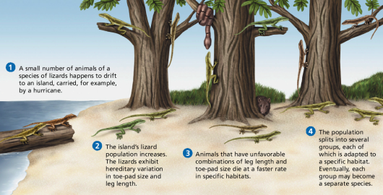

**Convergent Evolution**

* __________________________________*- process by which different species evolve similar traits.*
* They live in similar ecosystems and have similar pressures.
* **Similar but Separate –**while they may look similar their evolution occurred independently of one another.
* **Bird and bat wings.**

**Divergent Evolution**

* __________________________________*- process by which descendants of a single ancestor diversify into species that fit different parts of the environment.*
* Anole lizards twig-dwelling and trunk-dwelling
* Sometimes, a new population in a new environment, such as an island, will undergo divergent evolution until the population fills many parts of the environment.
* This pattern is known as __________________________________
* *Darwin’s finches.*

**Artificial Selection**

* __________________________________*– when a human breeder chooses individuals that will parent the next generation.*
* *Dogs*

**Evolution by Artificial Selection**

* **___________________________________** is the selective breeding of organisms, by humans, for specific desirable characteristics.
* Dogs have been bred for certain characteristics.
* Fruits, grains, and vegetables are also produced by artificial selection. Humans save seeds from the largest, and sweetest fruits. By selecting for these traits, farmers direct the evolution of crop plants to produce larger, sweeter fruit.

**Evolution of Resistance**

* **___________________________________** is the ability of an organism to tolerate a chemical or disease-causing agent.
* An organism may be resistant to a chemical when it contains a gene that allows it to break down a chemical into harmless substances.
* Humans **___________________________________**of resistant populations by trying to control pests and bacteria with chemicals.

**Pesticide Resistance**

* A pesticide sprayed on corn to kill grasshoppers, for example, may kill most of the grasshoppers, but those that survive happen to have a gene that protects them from the pesticide. These surviving insects pass on this resistant gene to their offspring.
* Each time the corn is sprayed, more resistant grasshoppers enter the population. Eventually the entire population will be resistant, making the pesticide useless.

**Pesticide Resistance**

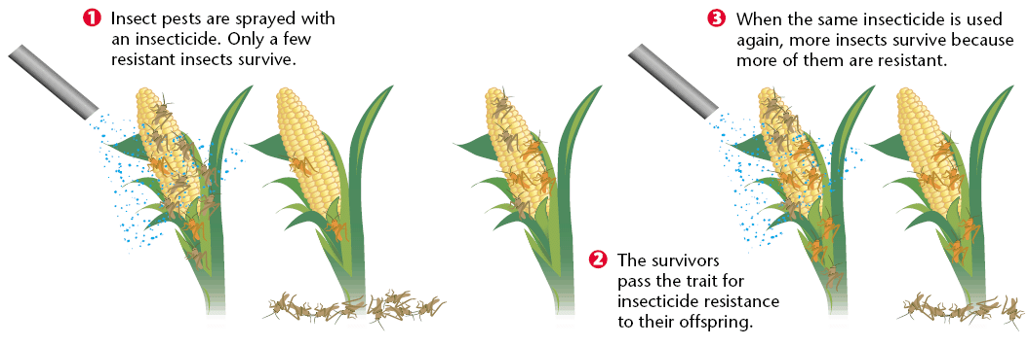

**Coevolution**

* __________________________________ *– when two or more species have evolved adaptation to each other’s influence*
* **Together, but Different**
* Acacia tree and acacia ant

**Coevolution**

* The honeycreeper’s adaptation is along, curved beak.
* The plant has two adaptations:
* The first is the **___________________________________**, which attracts the birds.
* The second is the flower structure that forces pollen onto the bird’s head when the bird sips nectar.

**3-3 Section Review Questions**

1. Explain how the anole lizard species on Caribbean islands demonstrates both convergent and divergent evolution.
2. What are the key differences and similarities between natural selection and artificial selection?
3. Give an example of species that are likely to be coevolving. Describe how each species influences the evolution of the other species.
4. Explain how a population of insects could become resistant to a pesticide.